# **CONTACT US VERSION 1.0**

## **Wireframes**

### **Contact Us Feature: (Public - Visitors View)**

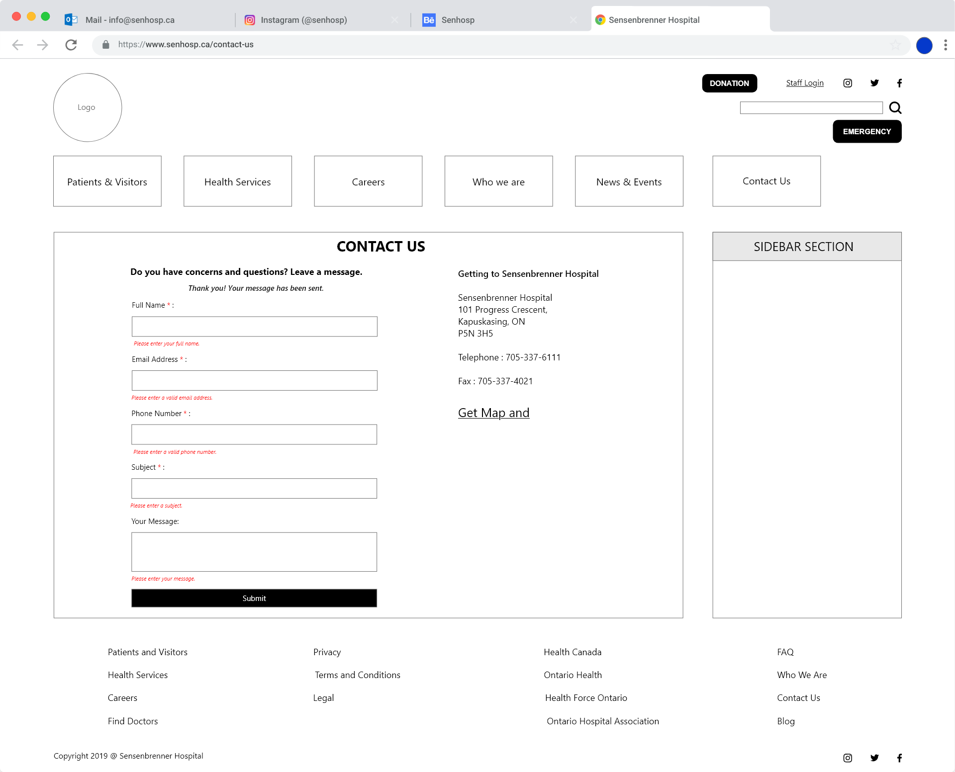 This will be a public page. No need to login to access the contact us form

### **Contact Us Feature: (Admin – List view of Messages)**

### this wireframe needs admin login. So the list view will be displayed and accessed

### **Contact Us Feature: (Admin – View Message/Update Message Status)**

Currently logged admin user can view the message and mark it as read and received

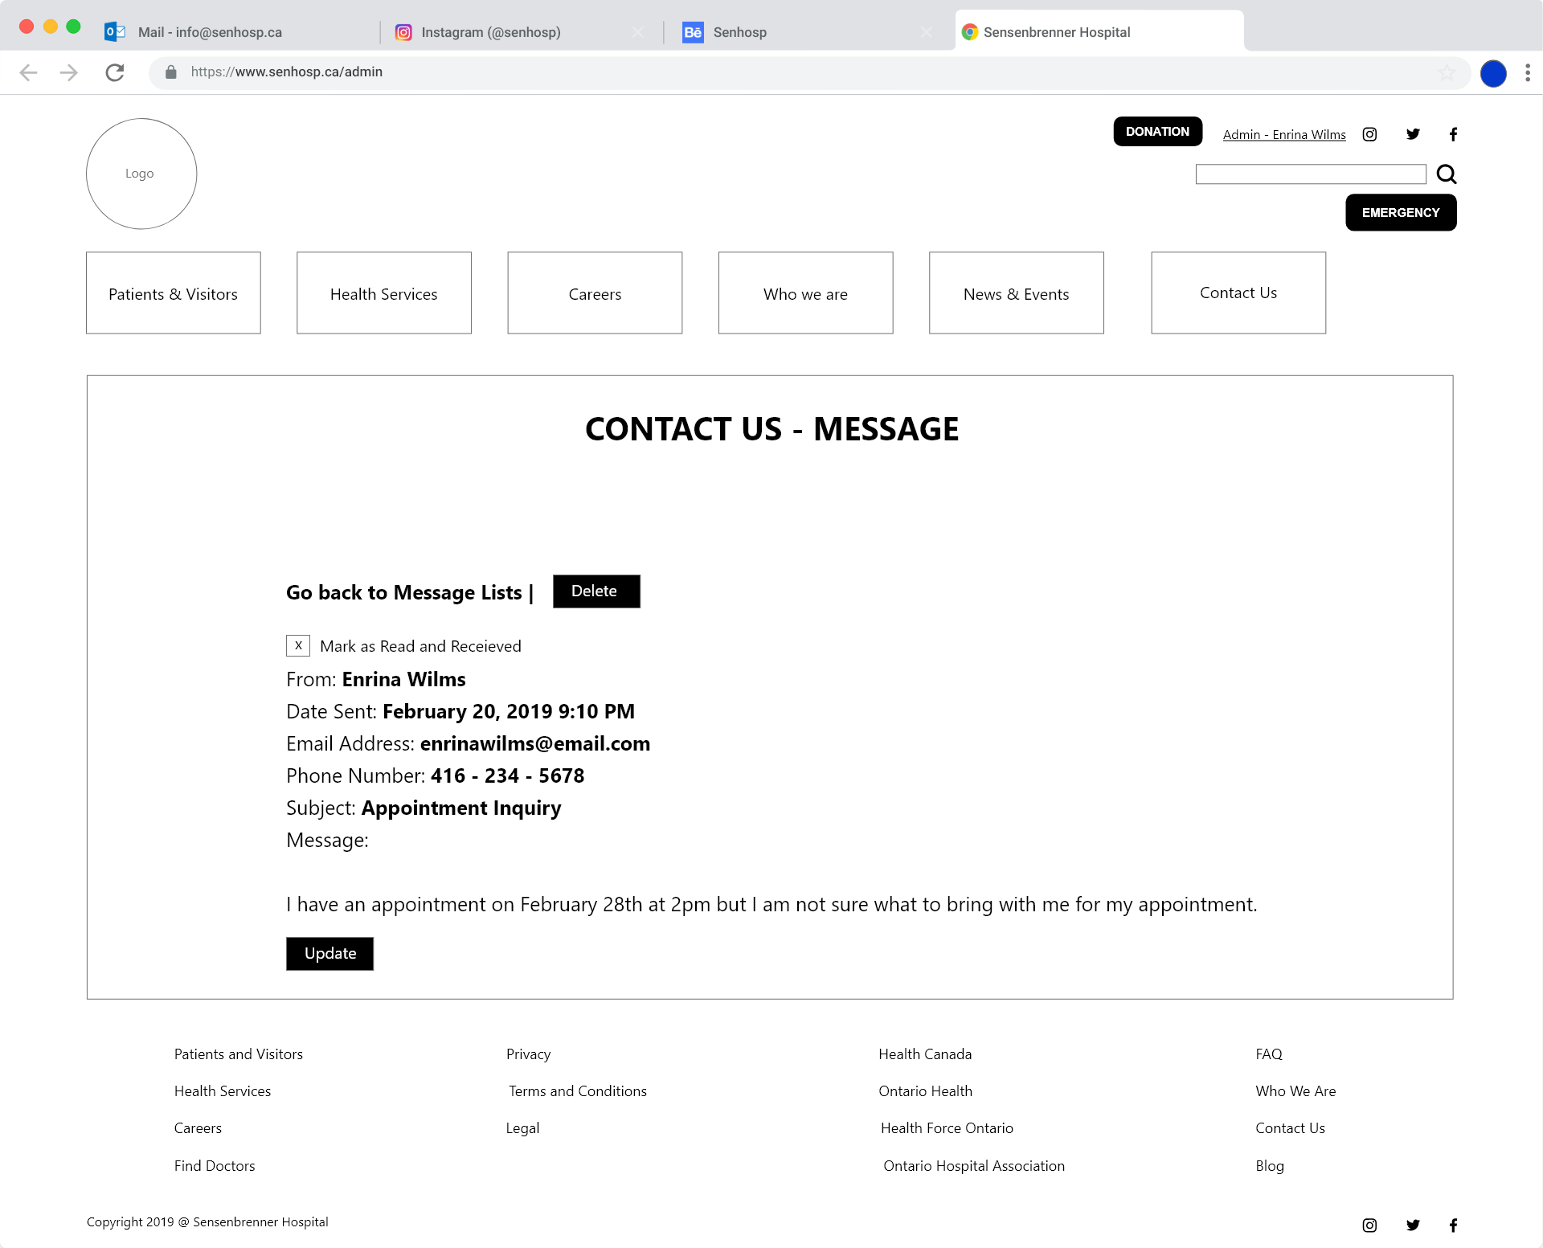

# **FREQUENTLY ASKED QUESTIONS VERSION 1.0**

## **Wireframes**

### **Frequently Asked Question Feature: Add New F.A.Q.**

Logged in admin user can add new FAQs

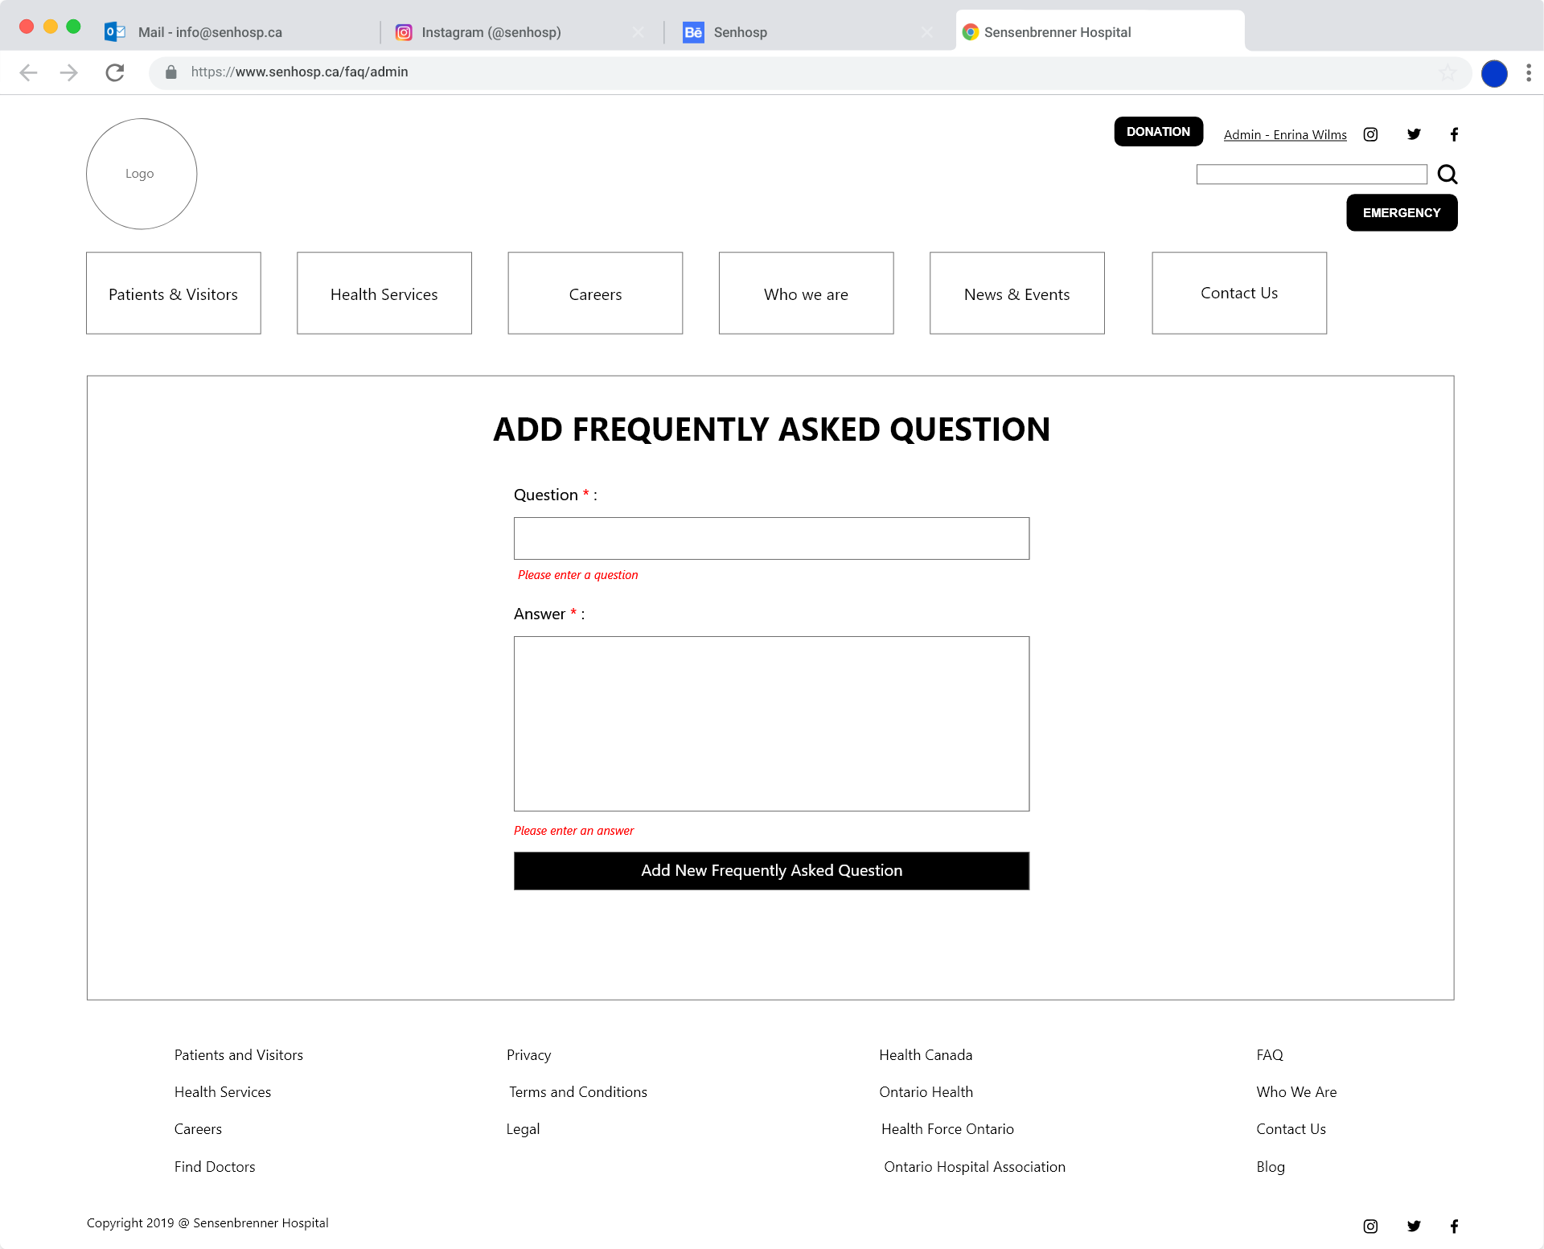

### **Frequently Asked Question Feature: Update/Edit F.A.Q.**

Logged in admin user can update new FAQs

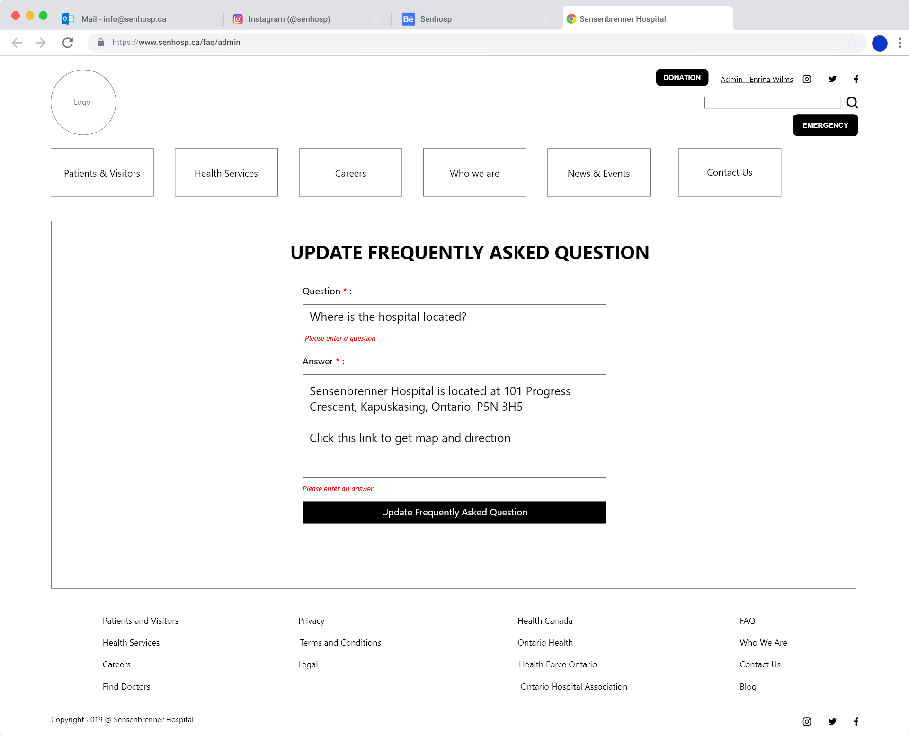

### **Frequently Asked Question Feature: Admin List View**

Logged in admin user can view the list of FAQ that’s currently stored from the database and can update or delete it.

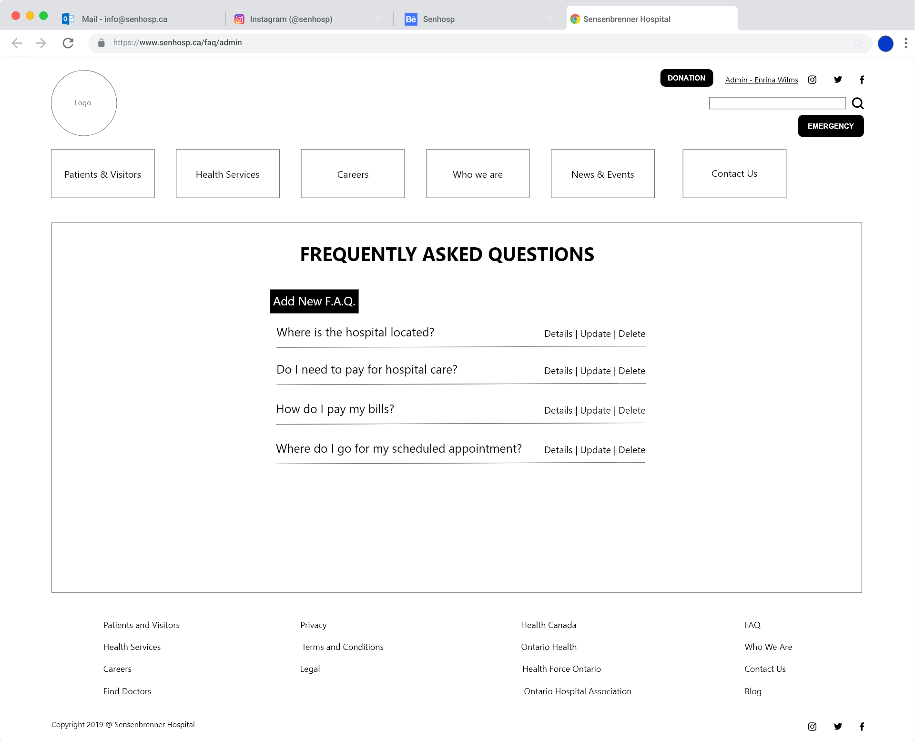

### **Frequently Asked Question Feature: Admin View F.A.Q. Details**

When an admin click an specific FAQ it will display the information stored from the database

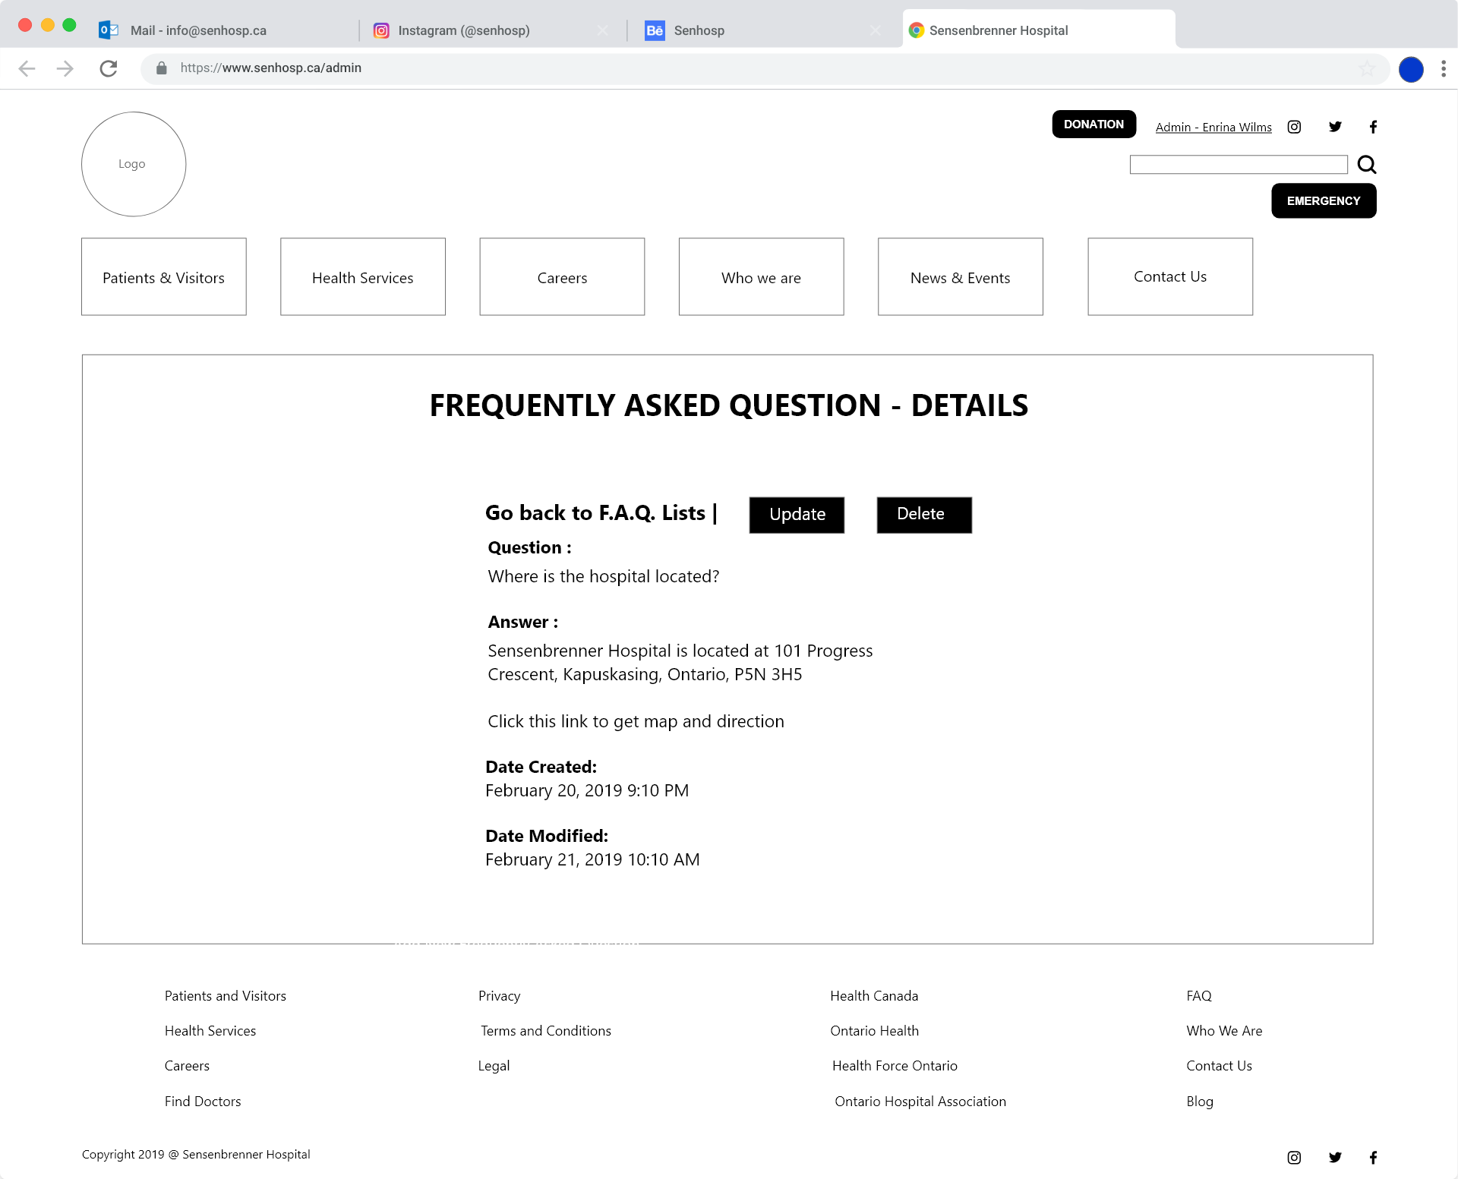

### **Frequently Asked Question Feature: Public List View**

This will be the public view for FAQs. It will be an accordion but I haven’t created this as my view. No need to be logged in as a user to view this.

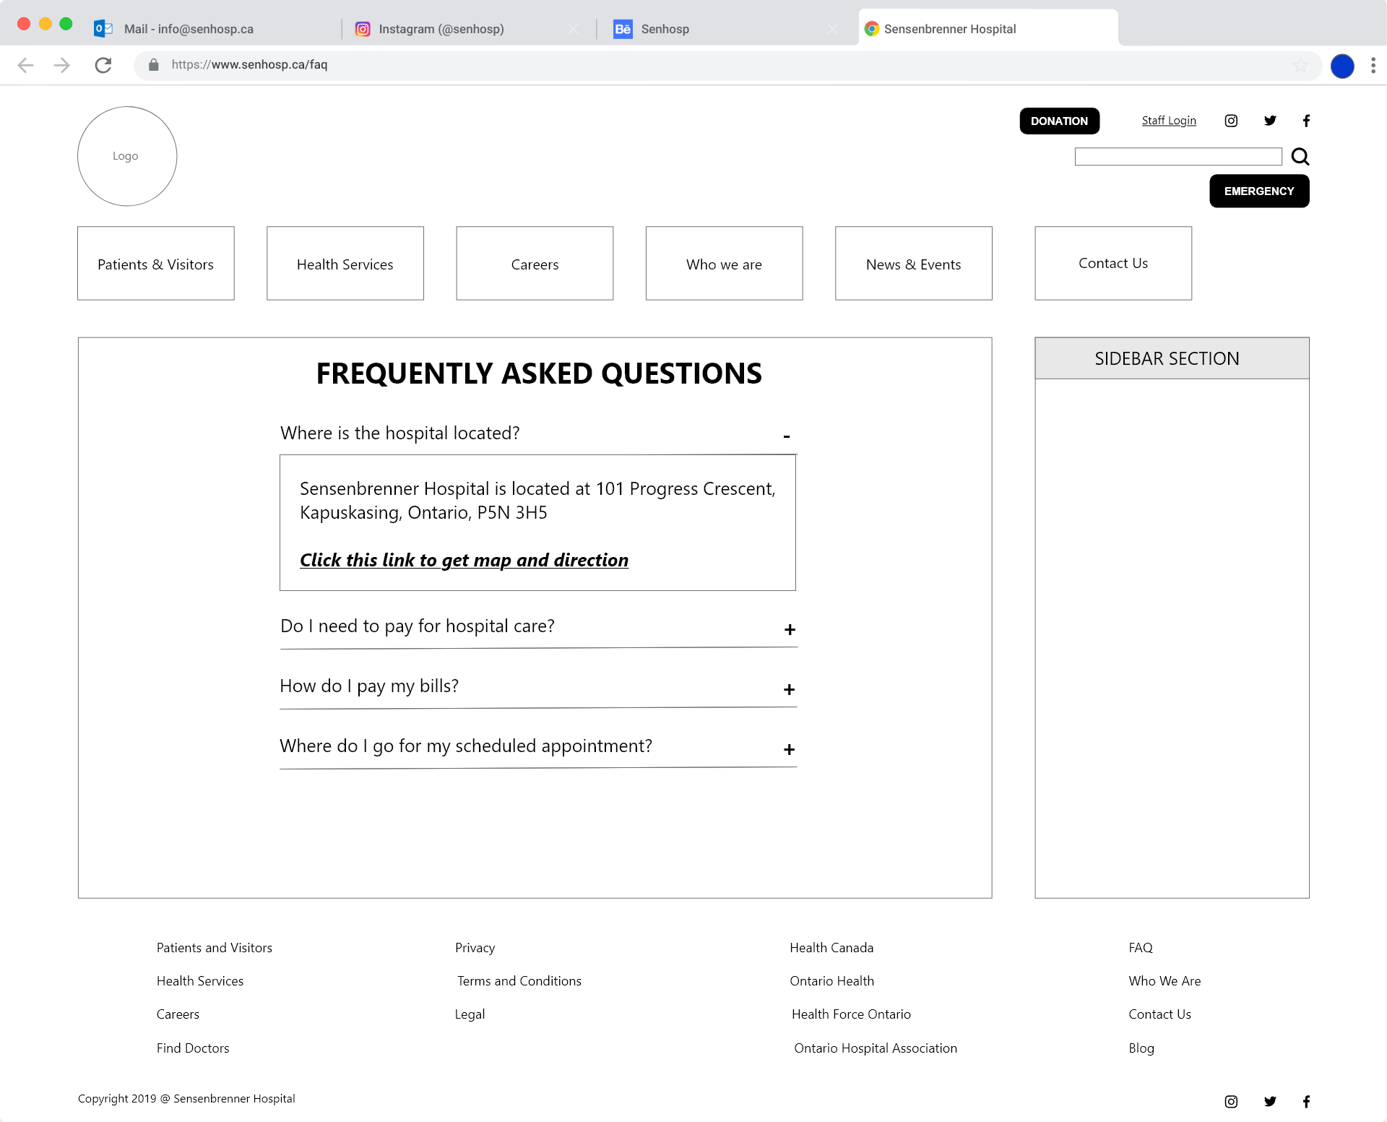

# **ALERT POST VERSION 1.0**

# **Wireframes**

### **Alert Post Feature: Add New Alert Post**

Logged in admin user can add new alert post

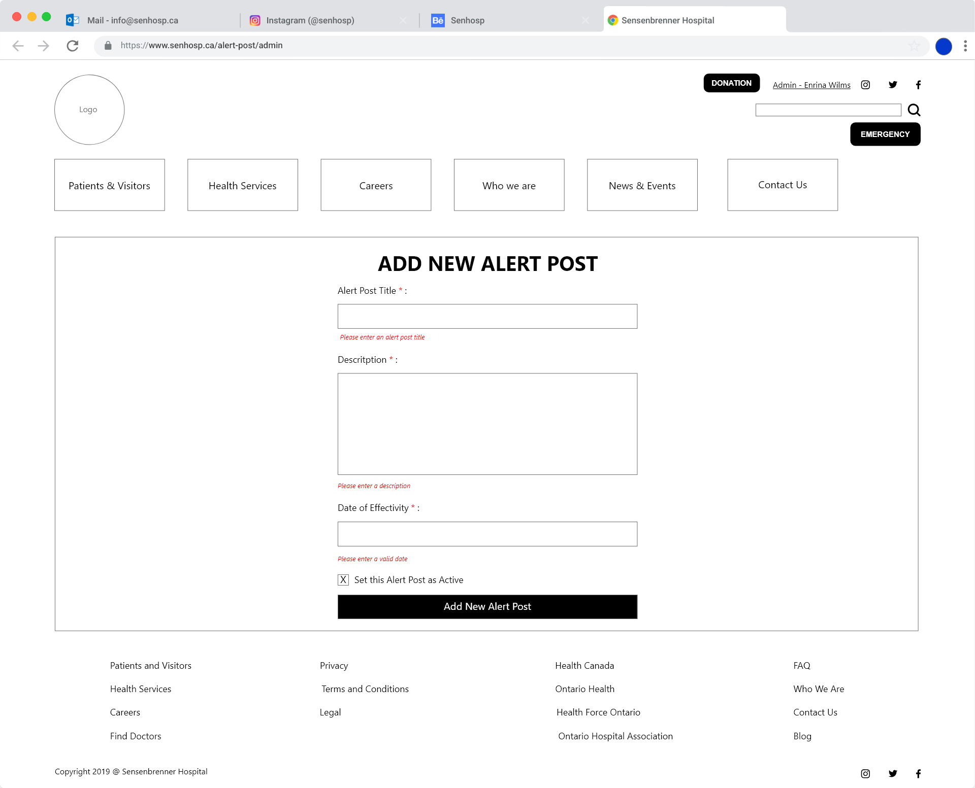

### **Alert Post Feature: Update Alert Post**

Logged in admin user can update an alert post if needed

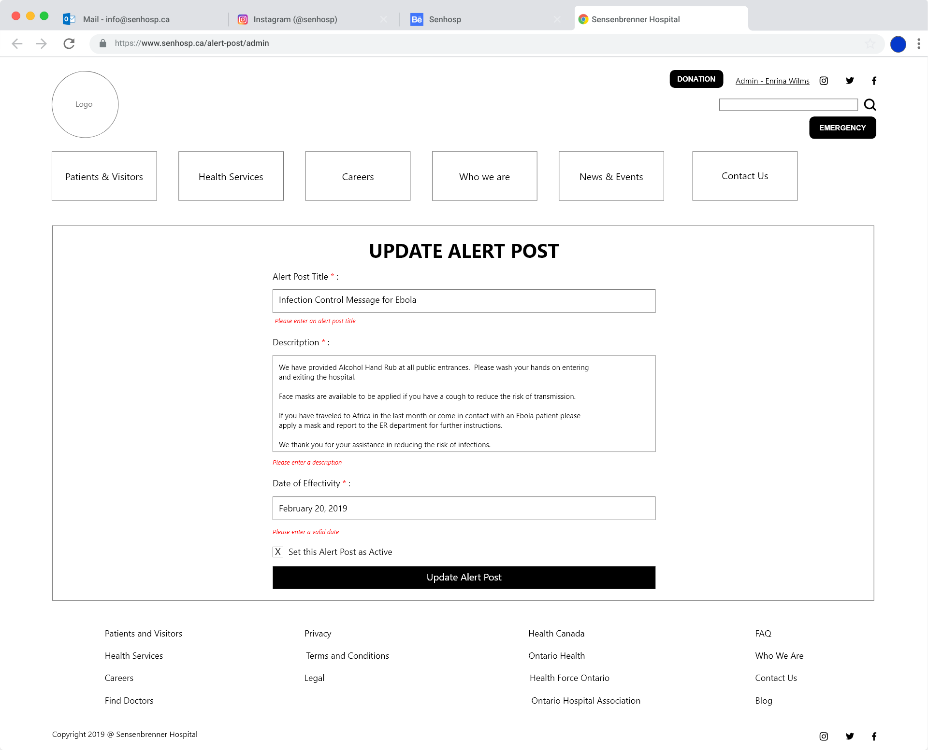

### **Alert Post Feature: Admin List View Alert Post**

Logged in admin user can view the lists of alert posts that’s currently stored in the database. Public users can’t see this.

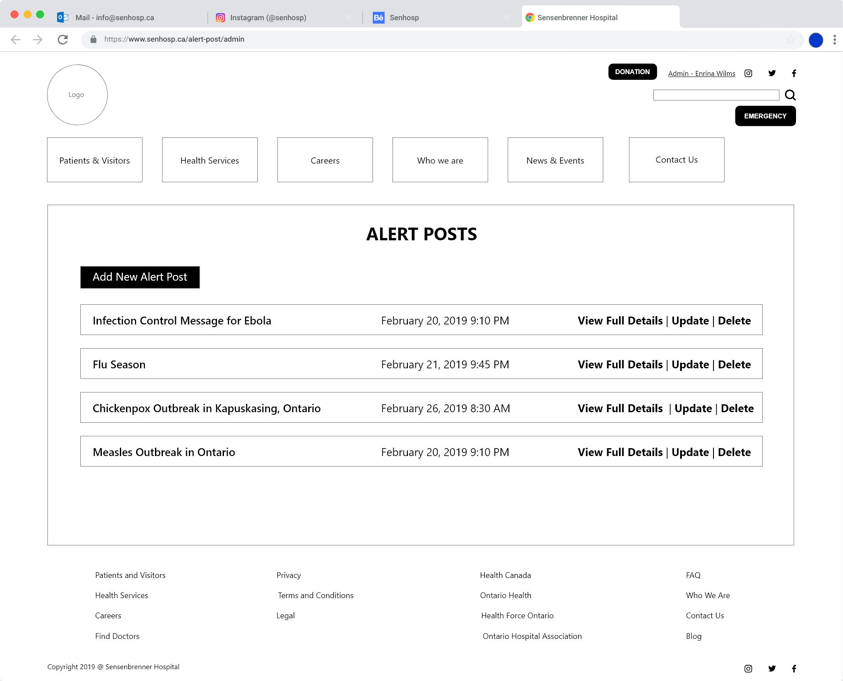

### **Alert Post Feature: Admin Full Details View Alert Post**

Logged in admin user can view the details of an specific alert post that was stored from the database. Details for admin and public users will be different.

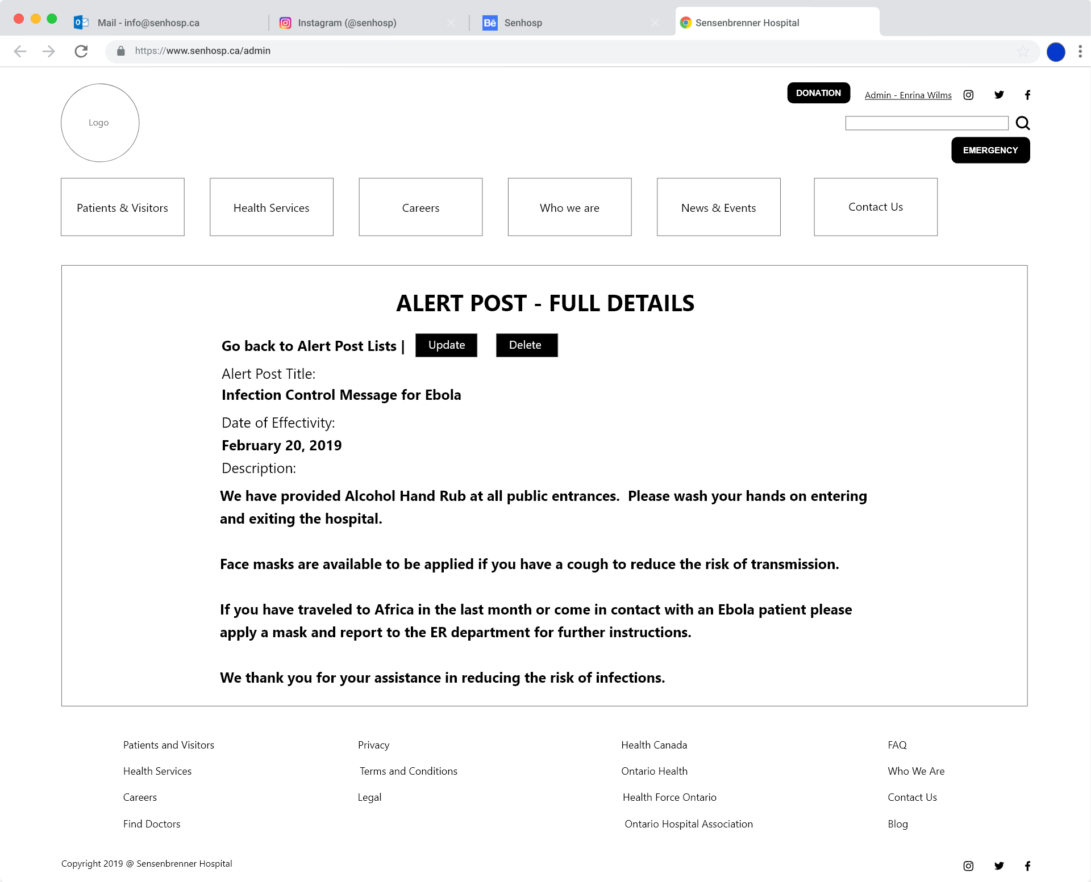

### **Alert Post Feature: Public View Alert Post in Homepage and Sidebar**

this will be the view for public users and visitors no need to logged in

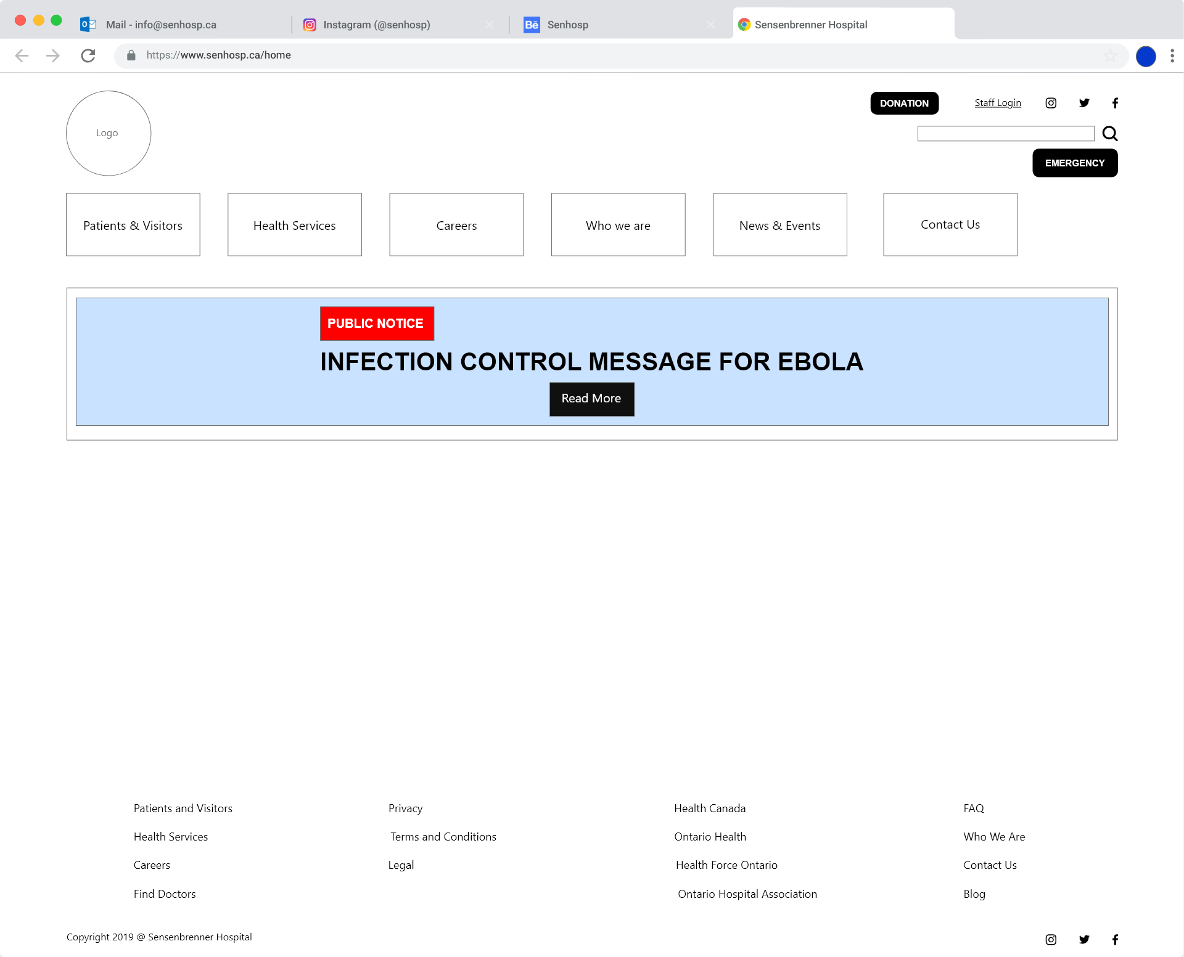

### **Alert Post Feature: Public View of Full Details Alert Post**

I haven’t created this view, but when a public user click the button this will display a full page information related to that alert post.

